
Lesson 10 Teacher's Key: Play It Again
GDevelop - Instructor Reference Only
VIDEO GAME CREATION

What This Lesson Teaches
GDevelop's "Or" condition as the mechanism for reuse this week - rather than a callable function, the SAME event group is simply reached via two different paths (scene start, or a restart flag), which is a genuinely different (and equally valid) way of achieving 'one place, two entry points.'

Level 1 - Full Worked Solution
- The Setup group's condition changes from an implicit "always run at scene start" to an explicit Or: [At the beginning of the scene] [RestartRequested = 1] - now genuinely reachable two different ways.
- RestartRequested is a one-frame flag: the new restart-key event sets it to 1, the Setup group (seeing it's 1) does the reset AND immediately sets it back to 0, so the group doesn't fire again next frame.
- GameActive = 1 added as a condition on the movement event is a minimal, single-line change that freezes movement without touching the movement action itself.
Highlighted lines are new this week; everything else is code you already have.
(Setup event group)
Condition: Or [At the beginning of the scene] [RestartRequested = 1]
Action: For each Enemy -> Delete Enemy
Action: Score = 0
Action: Lives = 3
Action: EnemiesRemaining = 5
Action: EnemyIndex = 0
Action: GameActive = 1
Action: RestartRequested = 0
Action: Hide WinText
Action: Hide LoseText
Action: Repeat 5 times -> Create object Enemy at (40 + EnemyIndex * 80, 40)
Action: EnemyIndex = EnemyIndex + 1 (inside the repeat)
(Enemy movement event, revised)
Condition: GameActive = 1
Action: Enemy.Y = Enemy.Y() + 30 * TimeDelta()
(Combat group - win check, revised)
Condition: EnemiesRemaining <= 0
Action: GameActive = 0
Action: Change text of WinText: "You Win! Press R to Restart"
Action: Show WinText
(Escape group - lose check, revised)
Condition: Lives <= 0
Action: GameActive = 0
Action: Change text of LoseText: "Game Over - Press R to Restart"
Action: Show LoseText
(new event)
Condition: Key R is pressed
Condition: GameActive = 0
Action: RestartRequested = 1
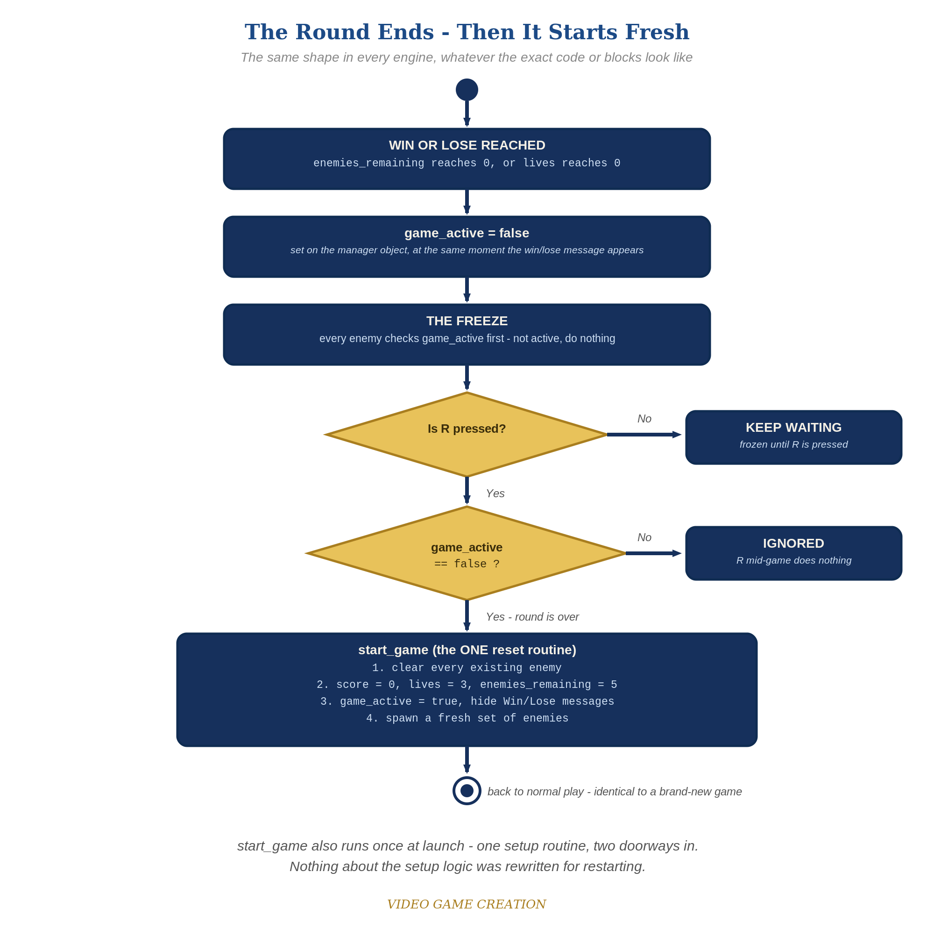
When the round ends, everything freezes - and R, pressed only while the round is over, runs the one reset routine. The same shape in every engine.

Why This Structure
- This is a genuinely different mechanism from Godot's start_game() function or GameMaker's Script resource - GDevelop's event-condition model doesn't need a named callable routine, just a shared condition that's true at the right two moments. Worth naming this as a real alternative, not a lesser version of 'having a function.'
- The RestartRequested flag pattern (set now, act on it this same frame, then clear it) is a common, reusable technique in event-based tools generally, useful again in future GDevelop lessons whenever a one-shot trigger is needed.

Level 2 / Level 3 Talking Points
- Ask students to compare this week's Or-condition approach against Godot's function call - both achieve 'one piece of logic, two ways to reach it,' just via different underlying mechanisms. A good moment to reinforce that the CONCEPT (reuse) matters more than which specific tool implements it.
- For strong students: ask what would happen if RestartRequested were never reset to 0 inside the Setup group - the group would keep re-running its reset logic every single frame forever, a good illustration of why clearing one-shot flags matters.
Level 2 - complete code:
// Level 2 is verification only - the Level 1 code is already correct, so no lines change.
// Checks: after a win and after a loss, R restores 0/3/5 with no leftover enemies; R during play does nothing.
Level 3 - code (additions highlighted):
Highlighted lines are the Level 3 additions on top of the Level 1 code.
// Level 3 visual: replace the instant Show with a Tween.
(Combat group - win check)
Condition: EnemiesRemaining <= 0
Action: GameActive = 0
Action: Show WinText
Action: Tween the opacity of WinText from 0 to 255 over 0.5 seconds

Common Student Mistakes
- Forgetting to reset RestartRequested to 0 inside the Setup group, causing a permanent reset loop the instant a restart happens.
- Adding the GameActive = 0 check to the restart-key event but forgetting the Key R is pressed condition (or vice versa) - both conditions are required together.
- Placing "For Each Enemy -> Delete Enemy" after the spawn action inside Setup instead of before it.

